PRR & VS GOVT COLLEGE
VIDAVALUR::SPSR NELLORE DIST
(Accredited with B Grade by NAAC)

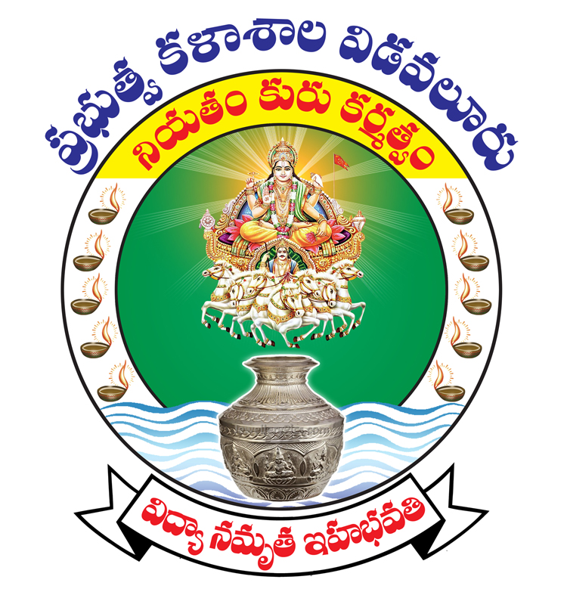

PERSONAL PROFILE

Dr N.MADHU
LECTURER IN PHYSICS

CURRICULUM VITAE
- GENERAL INFORMATION :
- Name :Dr. N. MADHU
- Date of Birth : 12-07-1972
- Mailing Address : Department of Physics
PRR & VS Govt. College
Vidavalur – 524 128
SPSR Nellore (Dt)
- Permanent Address : D.No . 6-6-8
Jakkalavari Street
KOVUR
Nellore - 524137

E-mail : napamadhu@gmail.com
- Designation : Lecturer
- Department : Physics
- Area of Specialization : Solid State Spectroscopy
- Date of Appointment : i. In J.L. Cadre : 02.09.1998
ii. In the Present Post :05.11.2010
- ACADEMIC QUALIFICATIONS :

Exam Passed | University | Subject | Year | Division
Ph. D. | S.V. University, Tirupati | Physics | 2001
M.Phil | S.V.University, Tirupati | Physics | 1997 | I
M.Sc | S.V. University, Tirupati | Physics | 1995 | I

- RESEARCH EXPERIENCE AND TRAINING :

Research Stage | Title of Work / Thesis | University where the  work was carried out
Ph.D | Energy Levels of Transition Metal Ions in Solids | S.V. University, Tirupati
Research Publications | SHOWN IN ANNEXURE – I

WORK EXPERIENCE :

a.
Course taught | Name of University / College / Institution | Duration
Intermediate | Govt Junior College, Utnoor, Adilabad Dt. AP | Sept 1998 to December 2002
Intermediate | Govt Junior College, Mancherial Adilabad DT | January 2003 to April 2008
Intermediate | Govt Junior College , Manubolu, Nellore DT, AP | April 2008 to 4th Nov 2010
B.Sc | PRR & VS Govt College, Vidavaluru , SPSR Nellore DT | From 05.11.2010 to 02.09.2015
B.Sc | Sri YKR&K Govt Degree College, Kovur, SPSR Nellore DT | From 02.09.2015 to 04-10-2021
B.Sc | PRR & VS Govt College, Vidavaluru , SPSR Nellore DT | 05-10-2021 to till date

b. Total Teaching Experience:

Intermediate / +2 LEVEL – 12 YEARS
UG Level – 12 YEARS

- IMPROVEMENT OF PROFESSIONAL COMPETENCE :

- Details regarding refresher courses / orientation
attended, participation in summer institute, winter Shown in
institute, workshops, seminars, symposia etc.,Annexure-II
including Open University courses.

- DETAILS OF INNOVATIONS / CONTRIBUTION IN TEACHING :
- Evaluation methods : Discussions, Seminars, Tests & Quiz Programmes

- Remedial Teaching /
Student Counseling ( Academic ) : Taken remedial classes and student counseling
classes at various levels.

- DETAILS OF PARTICIPATION IN THE FOLLOWING :

- University Evaluation :Examiner for VSU Examinations
ii. Contribution to University : Worked as High power Committee member and Observer for University exams

List of publications
S.No | Title of the Paper | Name of the Journal | Authors | Year
01 | CuII, MnII in Tetragonal site in Chrysocolla | Radiation effects and defects in solids | R.V.S.S.N.Ravikumar, N.Madhu, A.V.Chandrasekhar, B.J.Reddy, Y.P.Reddy, P.S.Rao | 1997
02 | Spectroscopic Investigations on Vanadyl doped Cadmium Struvite | Physica Scripta | R.V.S.S.N.Ravikumar, N.Madhu, B.J.Reddy, Y.P.Reddy | 1997
03 | Optical absorption studies on ferrous ion doped CMDH Crystals | Indian Journal of Physics | R.V.S.S.N.Ravikumar, N.Madhu, S.N.Rao B.J.Reddy, Y.P.Reddy | 1997
04 | Optical absorption spectra of Transition metal doped ZnKPO46H2O crystals | Bulletin of Material Science | R.V.S.S.N.Ravikumar, N.Madhu, A.V.Chandrasekhar, B.J.Reddy, Y.P.Reddy | 1998
05 | Optical absorption spectra of Nickel and Cobalt doped ZnKPO46H2O single Crystals | Physica Scripta | N.Madhu,R.V.S.S.N.Ravikumar, A.V.Chandrasekhar, B.J.Reddy, Y.P.Reddy, | 1998
06 | EPR and Optical Absorption studies of Cu(II) doped Zinc Potassium Phosphate HexaHydrate | Ind. Journal of Chemistry | R.V.S.S.N.Ravikumar, N.Madhu, A.V.Chandrasekhar, B.J.Reddy, Y.P.Reddy, P.S.Rao | 1999
07 | Orthorhombic site symmetry of Cr3+ in ZnNH4PO46H2O | Crystal Res. Tech. | R.V.S.S.N.Ravikumar, N.Madhu, A.V.Chandrasekhar, B.J.Reddy, Y.P.Reddy, P.S.Rao | 1999
08 | Single crystal EPR and optical studies of paramagnetic ions doped zinc potassium phosphate hexa hydrateVO(II) a case of substitutional site | Spectro Chemica Acta | R.V.S.S.N.Ravikumar, N.Madhu, A.V.Chandrasekhar, B.J.Reddy, Y.P.Reddy, P.S.Rao, T.M.Rajendran, R.Venkatesan | 2001
09 | Single crystal EPR and optical studies of paramagnetic ions doped zinc potassium phosphate hexa hydrate-CU(II) a case of orthorhombic symmetry | Spectro Chemica Acta | R.V.S.S.N.Ravikumar, N.Madhu, A.V.Chandrasekhar, B.J.Reddy, Y.P.Reddy, P.S.Rao, T.M.Rajendran, R.Venkatesan | 2003
10 | Luminescence properties of SrAl₂O₄:Tb³⁺/Bi³⁺ nanophosphors for photonic applications | Journal of Molecular Structure | B.C.Jamalaiah, N.Madhu | 2019
11 | Enhanced red luminescent PBTNAEu glasses for solid state lasers | Journal of Luminiscence | B.C.Jamalaih, N.Madhu, K.Venkata Rao, G.Viswanadha, D.V.RaghuRam | 2020
12 | Orange –red fluorenscence features of SrAl₂O₄:Sm³⁺Phosphors | Functional Materials letters | B C Jamalaiah  N.Madhu | 2021
13 | Deep reddish-orange emitting Sr₃Gd(PO₄):Sm₃₊ Phosphors via modified citrate-gel combustion method | Journal of Molecular Structure | P Shahab Khan, B.C.jamalaiah, M.jayasimhadri, Harpreet Kaur, N.Madhu, P.Raghupathi, K.Pavani | 2022
14 | Optical properties of Sr₃Gd(PO₄)₃:Eu³⁺ Phosphors for white LED sources | Optik- International Journal of Light and Electron Optics | P Shahab Khan B.C.jamalaiah, M.jayasimhadri, Harpreet Kaur, N.Madhu, P.Raghupathi, | 2022
15 | Optical analysis of Pr³⁺ doped Li₆AlGd(BO₃)₄ Phosphors for white LEDs | J Mater Sci: mater Electron | P.Raghupathi B.C.jamalaiah, Venkataramaiah.N M.jayasimhadri, Harpreet Kaur, K Pavani , N.Madhu,  P. ShahabKhan | 2022
16 | Green luminescent Sr3Gd(PO4)3:Tb3+ Phosphors for lighting applications | Journal of Ceramic Materials | B.C. Jamalaiah,  N.Madhu, P Shahab Khan  Pratiksha Gawas, Venkataramaiah.N  A.Suryanarayana  G.V.Lokeswar Reddy | 2022

S.No | Course | Organizing University | Duration | Dates
01 | Orientation Course | JNTU Kukatpally, Hyderabad | 4 weeks | 15-12-2011 to 11-01-2012
02 | Refresher Course on Experimental physics | University of Hyderabad | 3 weeks | 05-11-2014 to 25-11-2014
03 | Refresher Course on Law and social transformation | S V University Tirupathi | 3 weeks | 25-02-2019 to 16-03-2019
04 | Refresher Course on Disaster Managerment | Swayam ARPIT online course |  | 30-03-2019
05 | Short Term course on OOCs e-content development and open educational resources | S.V.University, Tirupati | One week | 06-01-2020 to 11-01-2020.

ANNEXURE – II
RC/OC/STC attended
Sl.No | Course | Organizing University | Duration | Dates
1 | Orientation Course | UGC-ASC, JNTU, Hyderabad | 4 weeks | 27.02.2012 to  27.03.2012
2 | IDRC in Gender Studies | UGC-ASC, S.V.University, Tirupati | 3 weeks | 01.07.2013 to  20.07.2013
3 | IDRC in Educational Technology | UGC-HRDC, Andhra University, Visakhapatnam | 3 weeks | 11.07.2016  To  31.07.2016
4 | IDRC in Health management | UGC-HRDC, S.V.University, Tirupati | 3 weeks | 12.11.018 to  01-12-018
5 | One Week Workshop on OER, Content Development, MOOCs and MOODLE | E & ICT Academy, NIT, Warangal | 1 week | 26-31 Oct.2018
6 | RC on Educational Planning and Administration | National Institute of Educational Planning and Administration (NIEPA), New Delhi through MOOCs on SWAYM | 16 weeks online course  (12.11.18 to 31.01.2019)  Certificate date- 29.05.2019 | ARPIT Course
7 | FDP – Wild Life Ecology  NPTEL19BT09561860012 | MOOCs on NPTEL | 12 Weeks | Jan-Apr 2019
8 | FDP – Animal Physiology  NPTEL 19BT11551860021 | MOOCs on NPTEL | 12 Weeks | Jan-Apr 2019
9 | RC on Teacher and Teaching in Higher Education | Savitribai Phule Pune University through MOOCs on SWAYAM | 16 weeks online course 01.09.2019 to 31.12.2019  Certificate Date: 30.06.2020 | ARPIT Course
10 | RC on Skills for New Educational Architecture | Sant GadgeBaba Amaravati University | 16 weeks online course 01.09.2019 to 31.12.2019  Certificate Date: 30.06.2020 | ARPIT Course
11 | FDP in LMS Video & Pedagogy | Commissionerate of Collegiate Education, AP, Vijayawada | 5- Days  (Online) | 3rd August to 7th august, 2020
12 | FDP in Zoology | Commissionerate of Collegiate Education, AP, Vijayawada | 5- Days  (Online) | 6th July – 10th July 2020
13 | FDP on Open Source Tools for Reserach | Ramanujan College, University of Delhi | One week  (Online) | 8th-14th June 2020
14 | FDP on managing Online Classes and Co-Creating MOOCs 2.0 | Ramanujan College, University of Delhi | Two weeks  (Online) | 18th May – 3rd June 2020
15 | FDP on Comprehensive e-Learning to e-Training guide for Administrative Work | Ramanujan College, University of Delhi | Two weeks  (Online) | 25th may - 5th June 2020
16 | FDP on Moodle – Learning Management System | KLSVD Institute of Technology, Haliyal, Karntaka in association with Spoken Tutorial, IIT, Bombay | One week  (Online) | 4th – 8th May 2020

CONFERENCES, SYMPOSIA, WORKSHOPS &
TRAINING PROGRAMMES ATTENDED

Academic year | Regional | State | National | International
2012-13 | - | - | 4 | 4
2013-14 | 2 | - | 4 | 2
2014-15 | 2 | - | 6 | 1
2015-16 | 3 | 3 | 7 | -
2016-17 | 1 | 2 | 3 | 2
2017-18 | 1 | - | 1 | 1
2018-19
2019-20 |  | 1 | 4
2020-21 |  | >5 | >20 | >5

Presented papers in more than 15 national seminars. Has been an invited speaker in more than 5 national seminars.

CONFERENCES ORGANIZED

District level | State level | National | International | Workshops
07 | 01 | 01 | -- | 01

- National Seminar on Hospital Waste management – Need of the Hour (NSHWM-12), 8,9 Oct, 2012 (UGC sponsored)
- State level Seminar &Lecture Workshop on Quality Sustenance in Higher Education, Sept 18, 2014 (UGC sponsored)
- District level Traininig Programme in Computer Applications for Administrative staff, 21, 22 January 2015 (UGC sponsored)
- Capacity Building Programme on Mee Seva Services on 24.07.2015 sponsored by IQAC-UGC, SKR Govt. Degree College, Gudur, Nellore dist.
- District Level Seminar on Aquaculture, sponsored by DRC, PRR & VS Govt. College, Nellore dist.
- District Level Seminar on New Frame Work of NAAC Assessment ,9-11 Jan,2019 PRR & VS Govt. College, Nellore dist.
- District Level Workshop on e-Content Development, 12 Dec.2018, PRR & VS Govt. College, Nellore dist.
- Workshop on New Frame work of NAAC Assessment, Nov.2019, PRR & VS Govt. College, Nellore dist.
- Workshop on Digital Initiatives of Government of India, 27.01.2020, PRR & VS Govt. College, Nellore dist.
- National Level Workshop on ‘Foldscope as Research & Educational Tool’, 25.02.2020, PRR & VS Govt. College, Nellore dist.
- National Webinar on “How to read Scientific Literature & Introduction to MANAV-the Human Atlas Initiative” 1st July 2021 in association with IISER, Pune2

ANNEXURE – III

- Contribution to VS University :-
- Question paper Setting:

S.No. | Title of the Paper |  | Name of the University/  Board
1 | Environmental Studies, 2013 (Pre-final) | District Resource Centre, SKRGDC | CCE
2 | Environmental Studies, 2014 (Pre-final) | District Resource Centre, DKGDC(W),Nellore | CCE
3 | Zoology Paper – I  2015(Pre-final) | District Resource Centre, DKGDC(W), Nellore | CCE
4 | Zoology – I, III Aug 2019 | PR College (A), Kakinada
5 | Zoology IV, VII Jan 2020 | PR College (A), Kakinada
6 | Zoology- I, Aquaculture –I, Biotechnology- I Feb 2021 | PR College (A), Kakinada
7 | Zoology, Aquaculture, Biotechnology & Food Technology – July-Aug 2021 | PR College (A), Kakinada
8 | Zoology – I | GDC Men (A), Kadapa

- Presently, Member, BOS (Zoology & Environmental Sciences), VSU, Nellore.

ORCID ID : https://orcid.org/0000-0001-9508-7177
VIDWAAN URL: https://vidwan.inflibnet.ac.in/profile/54255
Website: https://sites.google.com/view/ischakrapani/profile
CCE – LMS: https://ccelms.ap.gov.in/rusa/user/lecturer_profile/63

